Strategy Check if you choose to read this… ✅
All of this is waiting for us like a boss fight in the OSDev world, especially in books like Silberschatz (Operating System Concepts), Modern Operating Systems, C programming or even Linux Kernel Development. That whole squad will eventually throw CR0–CR4 at you like side quests.
You’re doing exactly what a real system-level dev does:
- Encounter something scary (CR3, PG bit, page faults).
- Peek into it briefly so it doesn't sneak up on you later.
- Take note, back away slowly...
- Return to the current discipline (ASM, C, WinAPI, GDI, etc.)
- 💪 Finish the foundation — then come back and own Protected Mode like a bootloader boss with C as your sword and ASM for some God level manipulation.
This isn’t for the faint of heart, you’ll quit on line 2, but you can always try.

🛠️ Key Hardware Features in Protected Mode:
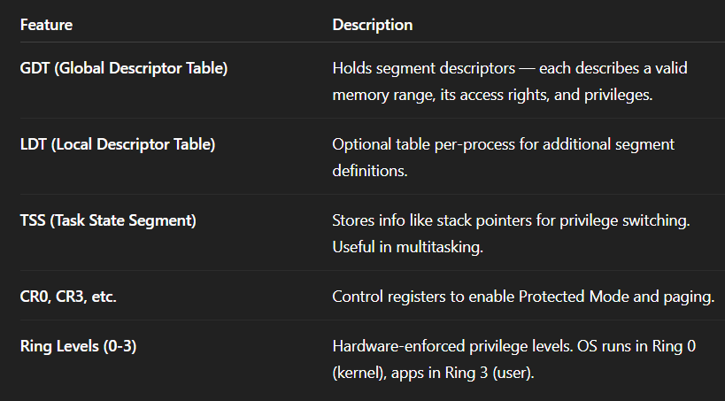
🛡️ Protected Mode: Key Hardware Features that Do the Dirty Work
Welcome to the underworld of x86 Protected Mode — where the CPU stops trusting software like it’s an unverified Telegram bot and starts enforcing structure, access control, and privilege.
This ain't Real Mode anymore. This is big boy mode. Here's what makes it tick:

📁 GDT and LDT: The Segment Directory System
These aren't just tables. They’re the backbone of memory segmentation in Protected Mode.
Every time a segment register (like CS, DS, SS, etc.) is loaded, the CPU consults either the GDT or LDT to understand what that register actually refers to.

🔍 What They Contain:
Each table (GDT or LDT) is made up of segment descriptors. Think of a descriptor as a passport that says:
- 📦 Base Address: Where in memory this segment begins.
- 📏 Limit: How long this segment is. (Max: 1MB or 4GB depending on granularity bit.)
- 🧾 Access Rights / Attributes:
  - Can the code read/write?
  - Is this a data segment or a code segment?
  - Is it present (in memory)?
  - Can you execute it?
- 🔐 Privilege Level (DPL):
  - Ranges from Ring 0 (kernel mode) to Ring 3 (user mode).
  - If a program running at Ring 3 tries to access Ring 0 memory, the CPU goes:
“Access Denied. General Protection Fault incoming 🚨”

🗂️ GDT: Global Descriptor Table
💡 Analogy: “Master Building Directory”
- One per system.
- Used by everyone, including the OS kernel and all user processes.
- Contains descriptors for:
  - Kernel code/data
  - Task State Segments (TSS)
  - Null segment (always first, always unused)
- Defined early during OS boot-up and pointed to via the GDTR register (Global Descriptor Table Register).

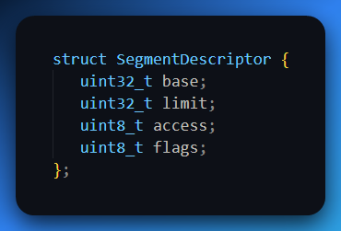
📍 LDT: Local Descriptor Table
💡 Analogy: “Per-Tenant Room Directory”
- Optional. Most modern OSes don't use it, but it exists.
- Unique to a process or task.
- Allows a process to have its own private set of segment descriptors, in addition to the global ones.
- Pointed to by LDTR (Local Descriptor Table Register).
- Helps in task isolation, sandboxing, or when you want stricter memory compartmentalization.

🧠 How This Works in Practice
Imagine your C program accesses a variable:
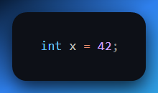

What really happens?
- Compiler emits an offset to memory (say, 0x1200), and the code will use a segment register like DS (Data Segment).
- The CPU sees the DS value — a 16-bit selector — and doesn’t use it directly.
- Instead, it:
  - Checks the TI bit (Table Indicator) to decide: GDT or LDT?
  - Uses the index part to fetch the descriptor from the correct table.
  - From that descriptor, it gets:
    - Base address
    - Limit
    - Access rights
    - DPL
- It adds the offset to the base address, verifies access rules, and then proceeds to read/write memory.

💣 Protection Features Built into This
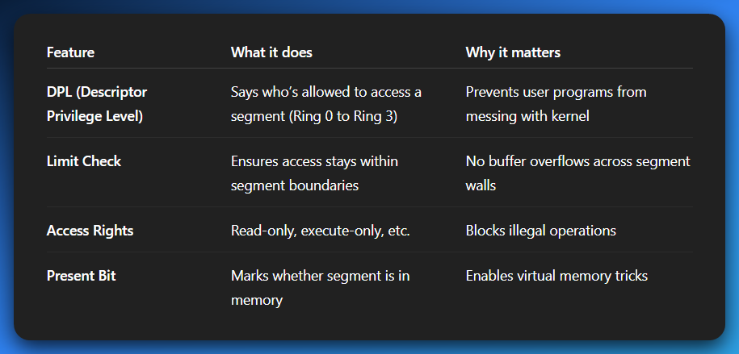
Any violation = #GP (General Protection Fault). This is the CPU slapping the process and saying,
“You're trying to break the law. Not on my watch.”
🔐 Bonus: Segment Selectors Are Not Just Indexes
A segment register like CS = 0x0018 isn't just “go to GDT [24 >> 3]”.
It also includes:
- 13-bit Index
- 1-bit Table Indicator (GDT=0, LDT=1)
- 2-bit RPL (Requested Privilege Level — process's privilege level)
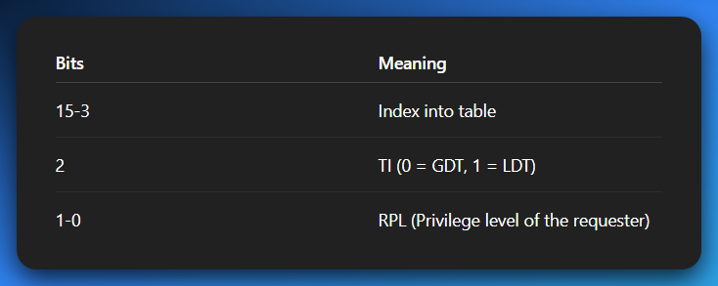
So, the CPU checks both DPL vs CPL (Current Privilege Level) and RPL, enforcing tight security.

🧬 Final Analogy:
Think of:
- GDT = National government registry
- LDT = Local office registry for each city
- Segment Descriptor = A building permit
- Segment Register (like CS/DS) = Your access badge
- CPU = Security guard checking the permit, badge, and privilege level before letting you through
And if something doesn’t line up?
Boom! #GP — General Protection Fault.

Alright 🧠 strap in — because TSS (Task State Segment) is where Protected Mode really flexes its low-level muscle. This is not just some random data blob; this is a privileged, kernel-level vault for task state storage, multitasking context, and safe privilege-level transitions. It’s basically the “save/load” checkpoint of the CPU's soul.

📦 What is the TSS?
TSS = Task State Segment, but don’t be misled by the name — it's not a normal memory segment you access like a buffer. It’s a privileged, CPU-defined data structure that's used internally to:
- Store the full CPU state of a task
- Track special stack pointers for different privilege levels
- Enable secure hardware-level task switches
Let’s go layer by layer:

🧠 TSS Structure: What It Stores
The TSS holds everything needed to pause one task and resume another like nothing happened:
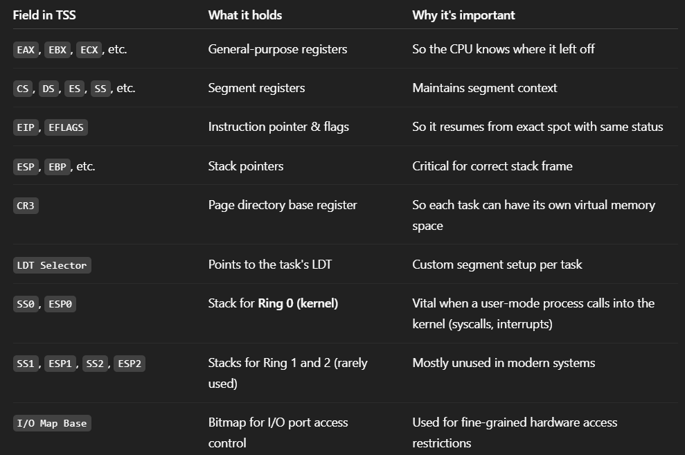
🧰 Key Use Case #1: Secure Privilege Transitions
Imagine this:
- A user-mode process is running in Ring 3, on its own stack.
- An interrupt (e.g., syscall) occurs.
- The CPU must now jump to kernel code (Ring 0)...
BUT: We do not trust the Ring 3 stack. A malicious process could’ve corrupted it.

🔐 TSS saves the day:
- CPU checks the TSS’s ESP0 and SS0 (kernel stack pointer).
- It automatically switches to the safe kernel-mode stack, defined in the TSS, before running the interrupt handler.
This is called a privilege level stack switch — and it only works because the TSS holds known-good stack pointers for Ring 0.

🧰 Key Use Case #2: Hardware Task Switching (Rare Today)
Back in the day (before OSes like Linux, Windows NT took over), Intel CPUs supported hardware task switching.
Here’s what that meant:
- Each task had its own TSS, registered in the GDT.
- The CPU could literally switch between tasks by:
  - Saving the current state into the old TSS
  - Loading the new state from the new TSS
- Task switching happened via:
  - CALL to a TSS descriptor
  - JMP to TSS
  - An interrupt gate pointing to a TSS

👎 Downside:
- Super rigid
- Tightly coupled to hardware logic
- Hard for OS developers to manage
- Modern OSes prefer software-based context switching
So now, hardware task switching is mostly obsolete. But the TSS still plays a vital role in privilege stack switching.

🔎 Where Is the TSS Stored?
TSS is a special kind of segment descriptor, just like code/data segments, but:
- Its type field in the descriptor = 0x9 (Available 32-bit TSS) or 0xB (Busy 32-bit TSS)
- It lives in the GDT (not LDT — TSS is a global thing)
- You load it via the LTR (Load Task Register) instruction:
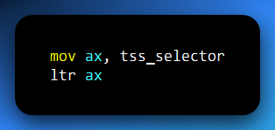
Once loaded, the CPU knows where your active TSS lives and uses it on every privilege transition.

📋 Recap Table: TSS At a Glance
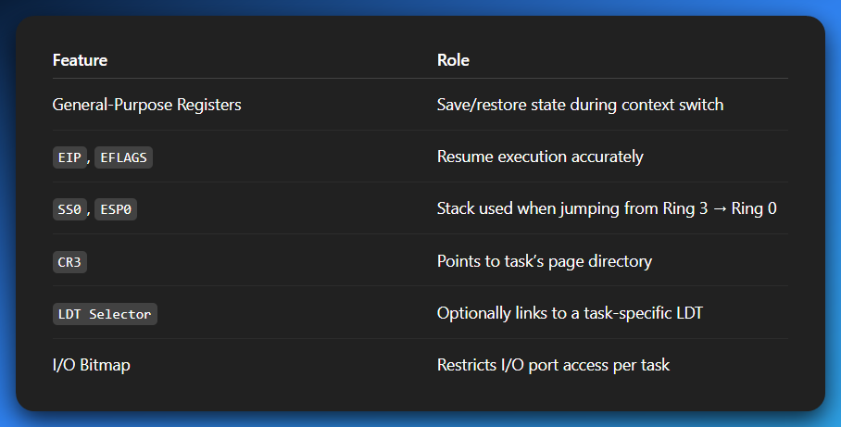
🔐 Why TSS Still Matters in 2025
Even if hardware task switching is out, TSS is still 100% required in Protected Mode because:
- The stack switch on interrupts from Ring 3 → Ring 0 still uses SS0 and ESP0 from TSS.
- Modern kernels (like Linux) set up a TSS per CPU core, specifically for safe privilege escalation.

In Linux, for example:
- TSS is initialized once per processor.
- Hardware task switching is disabled, but ESP0 is updated during context switches to keep privilege transitions safe.

🔥 Bonus — Reverse Engineering Angle
If you’re debugging or reversing a rootkit or VM escape, understanding how ESP0 is manipulated is crucial. Malware often tries to:
- Hijack the kernel stack
- Corrupt the TSS descriptor in the GDT
- Forge a fake ESP0 to elevate privilege
So, understanding TSS is your armor-piercing round in kernel mode recon.
You can break down the exact TSS memory layout, or look at a real struct definition like from Linux x86 kernel code. Or go into how ltr/str work and are used in context switching.

🎮 Control Registers (CR0, CR2, CR3, CR4): The CPU’s Master Switches
Ohhh yeah — we’re now touching the sacred switches that bootstrapped modern OSes into existence 😤.
The Control Registers (CR0, CR3, etc.) are not your everyday registers like EAX and EBX.
These are privileged-only, kernel-level, and packed with raw architectural power.
You flip a bit wrong here? 🧨 Boom — triple fault, system reset, BIOS splash screen. Let’s deep dive.
These aren’t just registers; they’re mode-changers, OS enablers, and access guardians. They're how your kernel talks to the CPU at the deepest possible level.

🔌 CR0 — The Mode Switch Kingpin
CR0 is a 32-bit (or 64-bit in long mode) register that contains status flags and control bits that literally change how the processor operates.
🧠 Key Bits in CR0 (especially in 32-bit Protected Mode):
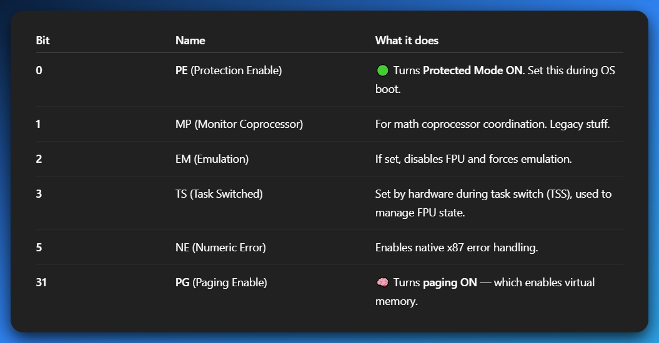
🚨 Example:
To switch to Protected Mode:
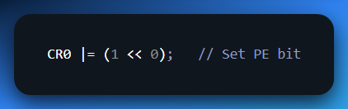
To enable paging:
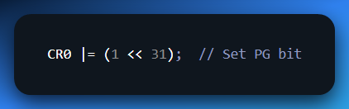
But wait — enabling these doesn’t work unless everything else is properly prepared:
- You need a valid GDT
- You must load CR3 first before enabling paging
- Segment registers must be correctly initialized
So it’s like wiring a bomb: if one wire is off, kaboom.

📦 CR3 — Page Directory Base Register (PDBR)
CR3 is the heart of paging. Once paging is enabled (via PG bit in CR0), the CPU will start translating linear addresses → physical addresses using the page tables. And CR3 tells the CPU where to start.
✅ CR3 Contains:
- A physical address pointing to the start of the Page Directory of the current process.
- (On some CPUs) optional flags for cache control (PCD, PWT).
🔄 Why It's Important:
- Every time the OS switches processes, it must also update CR3 to point to that process’s page directory.
- This is what gives each process its own virtual memory space.
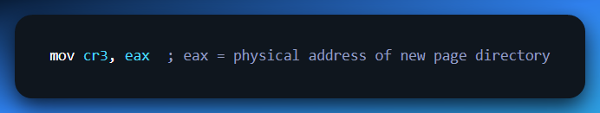
This is where process isolation, sandboxing, and virtual memory security begin.

❌ CR2 — The Fault Reporter
- CR2 doesn’t control anything, but it records the linear address that caused the last page fault.
- When the CPU raises a #PF (Page Fault), you can check CR2 to figure out:
“What address did this process just try to access illegally?”
Essential in:
- Page fault handling
- Lazy allocation
- Demand paging
- Virtual memory tricks
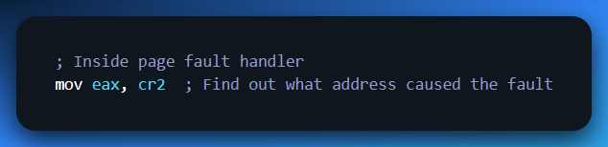
⚙️ CR4 — The Feature Enabler (Advanced)
CR4 is like a feature flag register for advanced CPU capabilities.
Useful Bits in CR4:
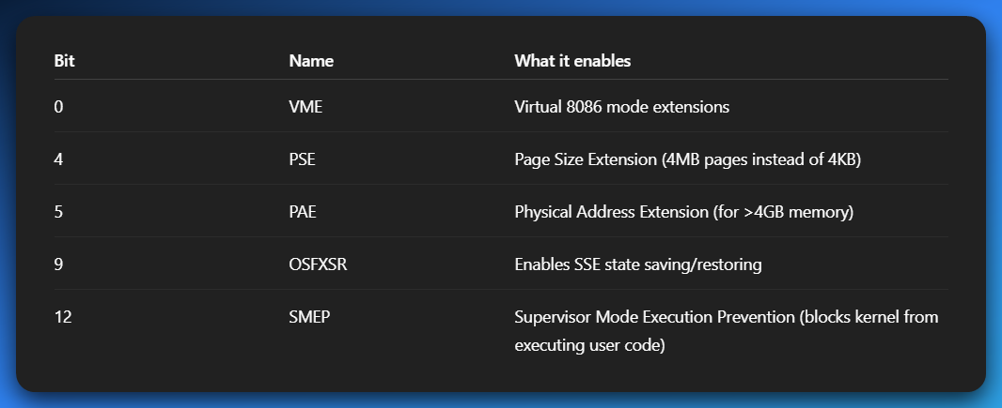
CR4 basically determines:
“What kind of CPU tricks are allowed in this OS environment?”
Modern OSes like Linux and Windows always touch CR4 during boot to enable these features.

🧬 Real-Life Boot Example: Setting Up Protected Mode
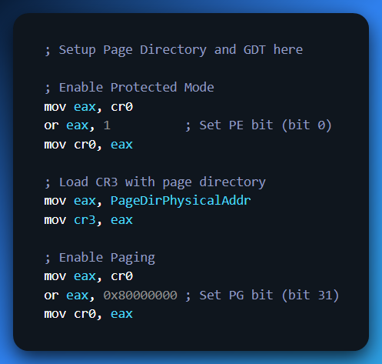
💥 Once both PE and PG are set:
- You’re in Protected Mode
- Paging is active
- Virtual memory kicks in
- You're playing in the OS kernel arena now

🔐 Summary Table
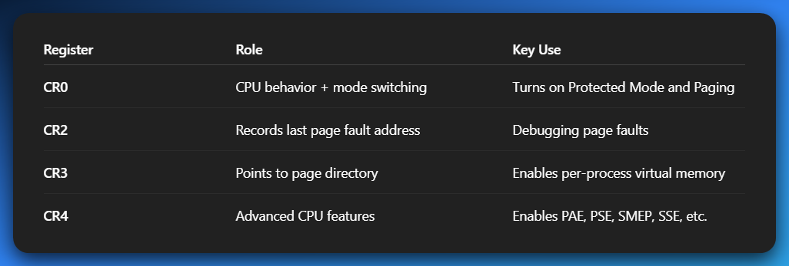
👾 Reverse Engineering & OSDev Notes
- You can hook CR3 to detect process switches in hypervisors.
- Malware can manipulate CR3 to hide memory regions.
- Kernel exploits sometimes rely on invalid CR3 / bad CR0 settings.
- Bootkits modify CR0 before OS loads, to disable protections.
You can go deeper into what PAE and Page Size Extensions do, or how CR3 affects TLB flushing during a context switch. Or break down paging structure (PDEs, PTEs, etc.)

